**Report on Fatalities and Injuries/Illnesses in the United States – 2012**

**Author: Shimaa Hamadelnel Institution: QuickStart Active Project Dates: Feb 26th, 2024 - March 10th, 2024**

**Executive Summary**

In 2012, the United States witnessed a significant number of fatalities and injuries across various domains. This report aims to provide an overview of these incidents, highlighting key statistics, trends, and potential implications for public safety.

**Introduction**

This report focuses to read the numbers of fatalities and injuries in the United States in 2012 through the federal and state program. The importance of understanding the different aspect between the elements and to take advantage of the data to apply safety knowledge on the states with higher records to maximizes the safety of the workplace, minimize human lost/injures and finally to reduce cost that follow incidences.

**Overview of Fatalities**

The total number of fatalities in 2012 was **4,617**, with **61% federal program** verse **39% of the state** program and that is a significant number of deaths in one year for workplace accidents.

`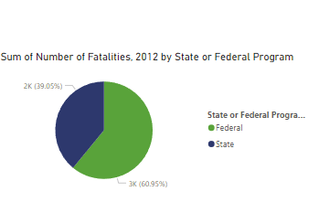

On the other hand, the cost of penalties is higher by the state program **59%** versefederal program **41%** for the year 2013 shown as follow:

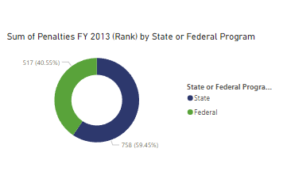

The histogram for the number of fatalities is rightly skewed, because two high numbers cause the chart to shift the distribution tail toward the right, also resulting in higher **mean 92** and smaller **median 69**. Outliers **536** & **375** have caused the peak of the distribution toward the left side. The majority of the states, about **75%**, have number of deaths less than **114** count.

**Business Problem:**

* What is the overall trend in the number of fatalities and injuries over the year 2012?
* Are there significant differences in the distribution of fatalities and injuries among various states?
* Is there a correlation between injuries and the occurrence of fatalities?
* Which program, state or federal, has the highest rate of fatalities?
* Which state with a state program has the highest number of injuries/illnesses?
* What is the relationship, if any, between “Average of Years to Inspect Each Workplace Once” and “Rate of Fatalities”?

**Data Sourcing**

The dataset we’ll be using is about workplace fatalities. Within this dataset you’ll find data points on fatalities, injuries, inspections, and penalties for each state in the US for the year 2012, the data set is available here:[2012_Workplace_Fatalities_by_State (1).csv - Google Drive](https://drive.google.com/file/d/1xeB3n0mfszEAEmygEZRvSEzfeqS7P_zv/view)

**Methods**Microsoftpower bi tools to summarize the data using pivot tables, slicers, visuals, and charts.Descriptive &inferential statistics “measures of central tendency measure of variability” using the Histogram and box plot whiskers diagrams.

**Results**

* **What is the overall trend in the number of fatalities and injuries over the year 2012?**

In 2012, there were **4,617** workplace fatalities in the United States. Additionally, **2,695,500** people were injured, and **86,394 $** sum of penalties.

The number of fatal work injuries varied significantly across different states in the United States. Here are some notable figures:

* **Texas**: Recorded the highest number of workplace fatalities with 536 deaths.
* **California**: Followed closely with 375 fatalities.
* **Florida**: Reported 218 workplace fatalities.
* **New York**: Had 202 fatal work injuries.
* **Pennsylvania**: Experienced 194 workplace deaths.

On the other hand, states like **Rhode Island** and **Vermont** had the lowest number of workplace fatalities, with only 7, 11 reported deaths.

* **Are there significant differences in the distribution of fatalities and injuries among various states?**

In most states, there is no significant difference between the distribution of fatalities and injuries except in two states. In Texas the number of injuries is way less than the number of fatalities, in contrast, California has the highest number of injuries than the number of fatalities.

* **Is there a correlation between injuries and the occurrence of fatalities?**

There is a strong positive correlation between the two variables, when the value of injuries increases the value of the fatalities increases too.

* **Which program, state or federal, has the highest rate of fatalities?**

North Dakota with 17.7 rate of fatalities, Federal program.

* **Which state with a state program has the highest number of** **injuries/illnesses?**

California with 345,400 injuries/illnesses

* **What is the relationship, if any, between “Average of Years to Inspect Each Workplace Once” and “Rate of Fatalities”?**

The coefficient r is close to zero, therefore, there’s no correlation between the two variables.

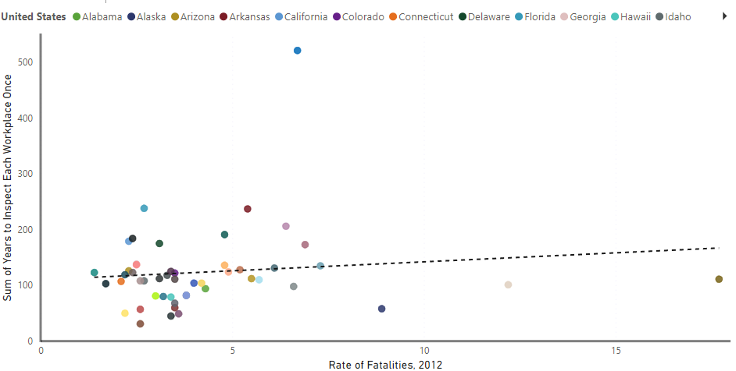

* The data below show the mismatch between the rate of fatalities and the number of fatalities in each state, it shows that **North Dakota** has the highest rate of fatality with 17.7 rate (65 death), followed by **Wyoming** 12.2 rate with (35 death). On the other hand, there is states have high death numbers & lower rate of fatality such as, **Texas** (4.8, 536 death), **California** (2.3, 375 death). The rate of fatality probably considers the number of the population and other factors that resulted in having this order.

* The last point to mention regarding the data, is that the number of inspectors increase in the workplaces has the high number of injures. In Nebraska state they had 9 inspectors during the whole year, with 24,300 injuries. While in California they had about 219 inspectors recording 345,400 injuries.

**Recommendations & Conclusions**

After diving & analyzing this data set, these numbers underscore the importance of workplace safety measures and vigilance in all states. States like California and Texas need to focus on improving safety measures and enforcing regulations to reduce fatality rates. Regularly collect workplace fatality data and analyze the data to identify trends, emerging risks, and areas for improvement. Invest in comprehensive safety training programs for workers across all industries.

**Ideas of improvement**

* The data set needs more accurate details, for example, the number of populations, type of incidents.
* Publish the power Bi report to the Power bi dashboard and pin the visuals and use the available tools.
* Use hierarchies to give the visuals drill up/down features.
* Key influencers visual could be a great tool to analyze such a data set.
* Put the data in star schema diagram would make the relationship between the dimensions clearer.